Aspirations Week

I would like to thank all of those who came in to talk to the Year 5 children last week about the world of work, careers and further education. We heard from: a financial planner, a barrister, a police officer, an emergency planner, a PhD student, a nurse, an employment consultant and a past pupil, who is currently training as a GP. It was great to see the children thinking about the future and gaining some real inspiration!


Stacey Copeland

We had another inspiring visitor this week: Stacey Copeland. After playing international under 18 football for England, Stacey went on to win a silver medal at the European Boxing Championsips. She was a real treat to listen to and I really hope that she has inspired more children (and girls in particular, to engage with sports!

Site Safety

After reviewing site safety in the light of recent events, we are (very) reluctantly considering enclosing the front field with fencing. Although we monitor the children very carefully on the field, we feel that we should isolate the play areas. We have had no incidents and no specific cause for concern, but we are very aware that we need to take greater steps reduce potential risk.
Please help us in the meanwhile by making yourself known to a member of staff before approaching your child at lunch or playtime. Staff can’t get to know every parent and a ‘stranger’ at the fence can spark an unnecessary alert.

We plan to enclose a lockable area for bicycles. Sadly, a bicycle was stolen by a member of the public last week. If you have any information on this please do let us know, in confidence. Please remember any bike is left in school at your own risk, but do encourage children to use a lock, which will give some additional security.

On a much more positive note, the children were fantastic during our fire drill this week. All classes were lined up outside exactly 4 minutes after the alarm sounded. All registers were completed and rooms checked within 6 minutes.
Term-Time Holidays

We need to tighten up our attendance procedures for next academic year. Please note that any absence of more than 5 days without medical evidence will be unauthorised. Any child with such an absence or anyone with an attendance rate below 95% may be subject to a series of steps as follows: a formal warning letter, fixed penalty notice (fine) and prosecution. Full details will be sent out before the end of term. Please do not book any term-time trips away: the school is unable to sanction them.

Destination High Schools

Children Leaving us this year will be attending: Burnage Academy for Boys (3), KD Grammar School ( 1), Levenshulme High School for Girls (4 ), Manchester Academy (1), Manchester Grammar School (2), MEA Central (8), Newall Green High (1), Parrs Wood High School , (14), Sale High School ( 1), Stretford Grammar School (1), Stockport School (1), Whalley Range High School for Girls (11), and William Hulme’s Grammar School (2). We are really pleased to se the opening of the new MEA Central which gives some of our parents a crucial additional choice.

Yet more Cricketing Success

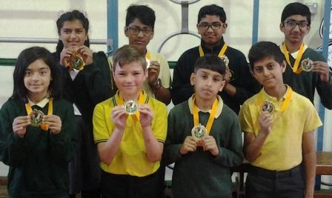
This week, whilst we were all occupied with our training day, some of our Year 6 children were busy winning the Didsbury Cricket Club Schools Competition. Mr Hudson was very proud of the children who participated and very happy indeed to come back to school with yet another trophy! Soe of the other schools had a number of regulars who play for DCC, so our victory was all the more pleasing! Well done!

Happy Eid

We would like to wish everyone who celebrates it a very happy Eid!

